# 7. “while” Loop

A **while** loop is usually used to repeatedly execute a statement/block of statements as long as a given condition is TRUE (nonzero).

Syntax



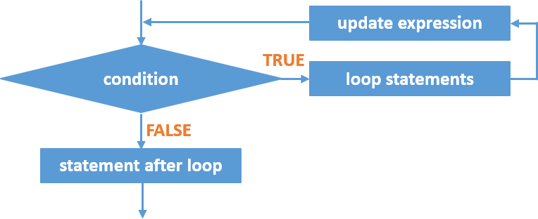

**while** Statement Flowchart

## How it works?

1. The **condition** is evaluated. The **condition** may be a direct integer value, a variable, or an expression.
   * Any nonzero value is considered TRUE.
   * If the **condition** contains a variable, the variable must be initiated before it is used.
   * If the condition is TRUE, the statements within the loop will be executed including the update expression.
   * If the condition is FALSE, the loop statements will not be executed. Program control jumps to the next statement after **while** loop.
2. The condition is evaluated again. Step 2 is repeated until the condition becomes false or loop is terminated using break statement.

Example:

/* program finds sum of all integer numbers from 1 to n, where n is entered by the user */

#include<stdio.h>

int main(){

int n, counter=1, sum=0; printf("Enter integer number: "); scanf("%d", &n);

while(counter <= n)

{

sum+= counter; counter++;

}

printf("Sum of integer numbers from 1 to %d = %d", n, sum); return(0);

}

# “do-while” Loop

* A **do-while** loop is usually used to repeatedly execute a statement/block of statements as long as a given condition is TRUE (nonzero).
* The **condition** is tested after execution of the **do-while** loop’s body 🡪 A statement/block of statements within the **do-while** loop will be executed at least one time.

Syntax



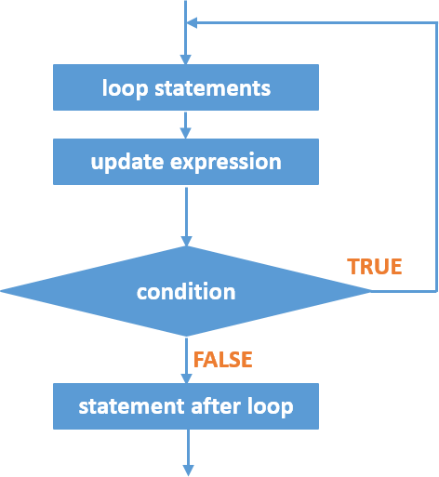

**do-while** Statement Flowchart

## How it works?

1. Statements, including the update expression, within **do** block are executed.
2. The **condition** is evaluated. The **condition** may be a direct integer value, a variable, or an expression.
   * Any nonzero value is considered TRUE.
   * If the **condition** contains a variable, the variable must be initiated before it is used.
   * If the condition is TRUE, the statements within the loop will be executed again, including the update expression.
   * If the condition is FALSE, the program control jumps to the next statement after **do-while**

loop.

Example:

/* program finds sum of all integer numbers from 1 to n, where n is entered by the user */

#include<stdio.h>

int main(){

int n, counter=1, sum=0; printf("Enter integer number: "); scanf("%d", &n);

do

{

sum+= counter; counter++;

} while(counter <= n);

printf("Sum of integer numbers from 1 to %d = %d", n, sum); return(0);

}

**References**

* Tan, H.H., and T.B. D’Orazio. *C Programming for Engineering & Computer Science*. USA: WCB McGRaw-Hill. 1999. Print.
* Tutorialspoint.com. "While loop in C." *Www.tutorialspoint.com*. N.p., n.d. Web. 13 Mar. 2017.

<<https://www.tutorialspoint.com/cprogramming/c_while_loop.htm>>.

* Tutorialspoint.com. "Do...while loop in C." *Www.tutorialspoint.com*. N.p., n.d. Web. 13 Mar. 2017.

<<https://www.tutorialspoint.com/cprogramming/c_do_while_loop.htm>>.